

**OPERATIONS ANALYTICS (7036SSL)**

**SUBMITTED BY**

**CLINTS THEEYATTUPARAMBIL JOHN**

**STUDENT ID – 13518992**

**MODULE LEADER - PINGFAN WANG**

**TABLE OF CONTENTS**

1.0 INTRODUCTION .............................................................................................................. 5

2.0 FORECASTING APPROACH AND FINDINGS ..................................................................... 6

2.1 TIME SERIES EXPLORATION ............................................................................................. 6

2.1.1 SEASONAL DECOMPOSITION ....................................................................................... 6

2.2 TIME SERIES MODEL BUILDING ........................................................................................ 9

2.3 TIME SERIES FORECASTING ............................................................................................. 11

2.4 SAFETY STOCK .................................................................................................................. 12

3.0 SIMULATION APPROACH & FINDING................................................................................. 13

3.1 EXPECTED LEAD TIME DEMAND FOR THE COMPANY ....................................................... 13

3.2 EXPECTED PROFIT FOR THE COMPANY ............................................................................ 14

4.0 CONCLUSION AND RECOMMENDATIONS ...........................................................................15

5.0 REFERENCE .........................................................................................................................16

**TABLE OF TABLES**

Table 1: Summary statistics of time series....................................................................................6

Table 2: Summary of the forecast ..................................................................................................12

Table 3: forecasting summary (training).........................................................................................12

Table 4: Calculation of Reorder point and safety stock ................................................................. 13

Table 5: share and probability .......................................................................................................13

**TABLE OF FIGURES**

Figure 1: Tesco Green Produce Demand............................................................ ……….5

Figure 2: Green produce demand and CMA-12 ...........................................................7

Figure 3: Detrend ........................................................................................................7

Figure 4: Seasonal variation.........................................................................................8

Figure 5: Noise ........................................................................................................... 8

Figure 6 : Moving avg and ABS erro.............................................................................9

Figure 7: SES and ABS error .......................................................................................10

Figure 8: LES and ABS error.........................................................................................11

Figure 9: Lead time and demand distribution............................................................. 12

Figure 10: Monte Carlo outcome..................................................................... ………12

1. **INTRODUCTION**

In the modern competitive world forecasting the customer demand is very crucial for every businesses. Accurate forecasting of the demand will help the companies to maintain their inventories properly. This study consists of the evaluation of dataset which includes monthly demand information for green vegetables sold by the company Tesco from the year 1992 to 2018.

Figure Tesco Green Produce Demand

One of the main objectives of the study is to find an efficient time series method to forecast demand and also calculate the reorder point and safety stock requirements. In this report I have used additive seasonal decomposition method instead of multiplicative to analyse the future demand. We use training and test data to compare the performance of three well-known time-series forecasting methods: moving average, single exponential smoothing, and linear exponential smoothing. To forecast inventory parameters, the most precise method will be chosen. Various error measures, including ME, MAD, MSE, RMSE, and MAPE, will be used to assess their accuracy. We can predict the lead time demand with the help of the exact forecasting technique we have chosen. This is important because it allows us to decide when to place our next purchase and maintain effective inventory management. To account for the difference in lead time demand, we will also determine the safety stock needed to maintain a 97% service level. We will use the Monte Carlo simulation method to achieve optimal profitability under various market scenarios while taking into account the projected lead time demand. These results will enable managers to improve inventory control and take well-informed decisions, ultimately boosting business revenue.

**2.0 FORECASTING APPROACH AND FINDINGS**

**2.1 TIME SERIES EXPLORATION**

Table Summary statistics of time series

The time series data that is shown in table 1 represents the demand for green produce with a mean of 236,468 units and a standard deviation of 27,395. The minimum demand observed is 160,204 units, and the maximum is 288,145 units, resulting in a range of 127,941 units. The median demand is 240,580.5 units, while the mode, the most frequent value, is 227,899 units. There were a total of 324 datapoints in the time series. A coefficient of variance of 0.115 states that the datapoints have relatively low variability compared to the mean.

**2.1.1 SEASONAL DECOMPOSITION**

With the help of the seasonal decomposition approach, time series analysis, it is possible to separate a series into its level, trend, seasonality, and noise systematic components. This is important for forecasting and modelling time-dependent phenomena since it aids in a better understanding of the underlying patterns and changes in the data. Seasonality and other elements of the data are separated from repeated short-term cycles. Brownlee, J. (2020, December 9).

I have given consideration to additive over multiplicative decomposition since additives are more appropriate when the seasonal variations are constant at the times mentioned.

Figure Green produce demand and CMA-12

Green Produce Demand and CMA-12 are compared through time in the figure 2. In this the trend has been calculated using the 12 month moving average method. Demand for green produce starts at 250 000 and rises over time. Similar rising trend is seen starting around 200,000 in CMA-12. It appears that there may be a connection between the two elements because of their positive correlation.

Figure Detrend

The figure 3 depicts a time series of data points from January 1992 to May 1993. The values of the data points changes with a distinct seasonal pattern. Values of the datapoint indicate a negative trend over the time. The seasonal index measures the degree of deviation from the trend at various intervals during the year.

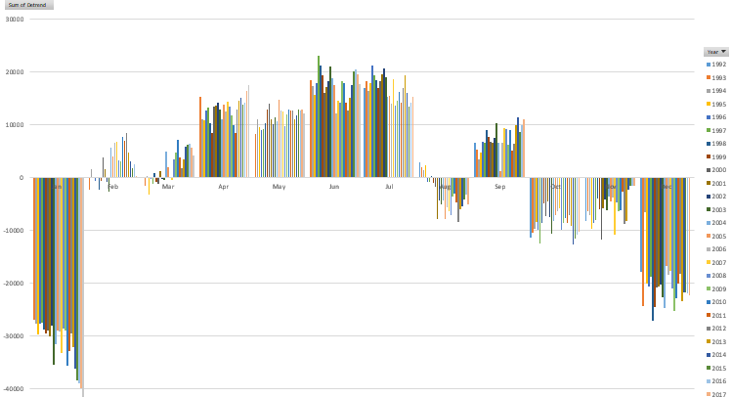

Figure Seasonal Variation

The figure 4 depicts seasonal fluctuation using a detrended dataset. The values of the detrended datasets varies according to the trend.

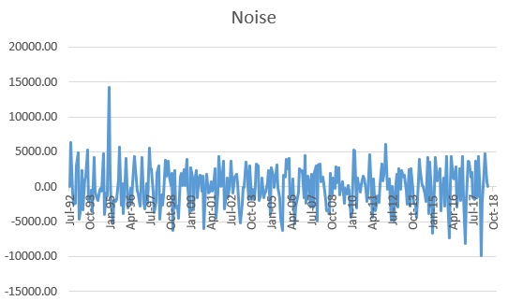

Figure Noise

The next step is to calculate the noise (figure 5) of the datapoints. Analysing the noise will help to find the erratic fluctuations in the datapoints. To calculate the noise, the trend and seasonal components are subtracted from the raw data.

**2.2 TIME SERIES MODEL BUILDING**

In time series model building the predictions are made by analysing the sequential data of the past. During this approach, the data is separated into two subsets: one for training the model and one for evaluating its performance. Typically, prior data is used for training. The allocation to each set is determined by the split ratio. The test set contains the most recent 12-period data, whereas the training set contains the rest in reverse order.

Moving average method is one of the popular time series forecasting technique. By calculating averages of successive data points, the moving average method smoothes out short-term variations. It aids in identifying underlying trends and patterns in data, which aids in generating future forecasts. This strategy is especially beneficial when the data is seasonal or cyclical. However, it may miss more intricate correlations or abrupt changes in time series data. Hansun, S. (2013).

Figure 6 depicts the relationship between the green produce demand , MV-12 and the Abs error.

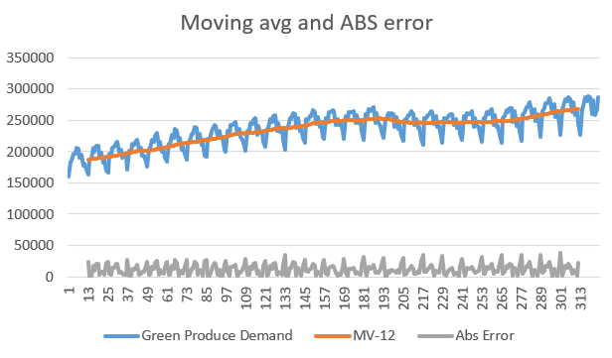

Figure Moving average and abs error.

Simple exponential smoothing is a popular and a widely used forecasting technique. It is mainly used when the data does not have a significant trend or seasonality. In this approach the recent data is given more priority than the older data. The approach works by adding exponentially decreasing weights to previous observations, with more recent data receiving a higher weight than earlier data.

Following is the equation of simple exponential smoothing:

**Forecast(t+1) = α * Actual(t) + (1-α) * Forecast(t)**

Since a smaller alpha value gives more weight to the recent data, I have considered **0.2** as the alpha value. Figure 7 shows the line graph of SES, Absolute error and green produce demand.

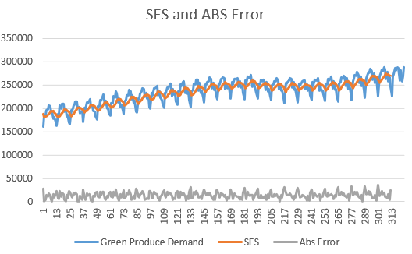

Figure SES and ABS error

Linear exponential smoothing is a technique for forecasting future values based on past data. It makes use of two factors: the average of previous data (level) and the direction in which the data is going (trend). The formula combines these to get a prediction. It prioritises current data while taking the general trend into account. The alpha () and beta () parameters (**both set to 0.2**) determine how much weight is assigned to fresh data and trends. As a result, the projection is a combination of previous and present data, with recent data having a little greater impact.

The following is the formula of the linear exponential smoothing:

**Forecast(t+1) = Level(t) + Trend(t)**

**Level(t) = alpha * Observation(t) + (1 - alpha) * (Level(t-1) + Trend(t-1))**

**Trend(t) = beta * (Level(t) - Level(t-1)) + (1 - beta) * Trend(t-1)**

Figure 8 shows the relationship between the Green produce demand, Linear exponential smoothing and the absolute error.

Figure LES ABS Error

**2.3 TIME SERIES FORECASTING**

Time series forecasting is a strategy for predicting future values based on past observations collected at regular time intervals. It is frequently utilised in a variety of sectors like as finance, economics, weather forecasting, and others.

**ME (Mean Error)** is a metric that calculates the average difference between actual and predicted values. ME values near zero imply good forecasting accuracy.

**MAD (Mean Absolute Deviation)** computes the average of absolute forecast errors while ignoring mistake direction. It gives you an idea of the typical magnitude of errors.

The average percentage difference between actual and anticipated values is calculated using **MAPE (Mean Absolute Percentage Error).** It expresses forecasting inaccuracy as a proportion of actual values, allowing for more accurate comparison across datasets.

The **RMSE (Root Mean Squared Error)** is an extensively used statistic. It is used to measure the average of the squared forecast errors.

Given below is the summary of the forecast and the forecast summary (training) based on the forecasting methods of moving average, Seasonal exponential smoothing, and linear exponential smoothing.

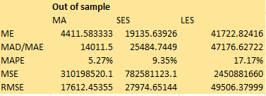

Table Summary of the forecast

The forecast summary presented here in the 2 compares the performance of three forecasting methods: MA (Moving Average), SES (Simple Exponential Smoothing), and LES (Linear Exponential Smoothing). The table offers several indicators for evaluating their correctness and dependability. The lower the MAD/MAE, MAPE, MSE, and RMSE values, the greater the forecast accuracy**. MA(moving average) has the lowest RMSE, indicating that it is the best at predicting data points.** SES is close behind, with a little higher RMSE. LES has the largest RMSE and executes the least accurately. Stakeholders should evaluate these indicators while selecting the best forecasting approach for their specific needs and data characteristics.

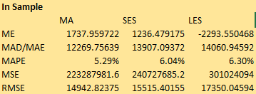

Table Forecasting summary (Training)

The table 3 provides a summary forecast of training data using three evaluation metrics: Mean Absolute Error (MAE), Mean Absolute Percentage Error (MAPE), and Root Mean Squared Error (RMSE). Forecast performance varies by region: MA, SES, and LES. Overall, the model's predictions for MA have a reasonably low MAPE of 5.29% and an RMSE of 14,942.82, showing reasonable accuracy. However, the MAPE values for SES and LES are higher, at 6.04% and 6.30%, respectively, indicating significantly less accuracy. The RMSE values for SES and LES are 15,515.40 and 17,350.05, respectively, showing higher mistakes in projections for these regions.

**2.4 SAFETY STOCK**

Safety stock is one of the important part of the inventory management systems. It helps to analyse the additional stock retained as buffer stock to minimise the uncertainties in demand and supply lead times. It helps the firm to ensure the availability of the product even if there are delays. Some of the parameters to determine the degree of safety stocks are desired service levels, demand unpredictability, and lead time variance. Proper utilization of the safety stock helps to increase the supply chain performance and the customer satisfaction. Inderfurth, K. (1991).

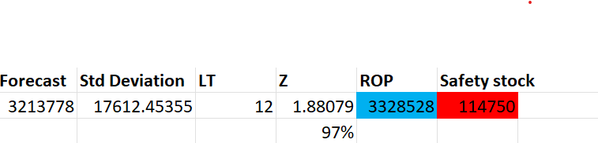

Table Calculation of reorder point and safety stock

The table 4 shows the calculations for safety stock and reorder point based on historical demand data. With an anticipated demand of 3,213,778 units and a standard deviation of 17,612.45 units, a 97% service level is targeted using a Z-score of 1.8808 for a 12-unit lead time. The safety stock is discovered to be 114,749.72 units, and the reorder point is 3,328,527.72 units. These values help the company to optimise inventory levels, assuring efficient operations and customer pleasure by preventing stockouts throughout the lead period.

**3.0 SIMULATION APPROACH & FINDINGS**

For the Simulation approach Monte Carlo simulation is used. It is a method of using random sampling to assess the results. Monte Carlo simulation runs number of simulations inorder to obtain the best possible result. It is very useful for the business to mitigate their risk. It helps them to make intelligent decisions. Raychaudhuri, S. (2008).

**3.1 EXPECTED LEAD TIME DEMAND FOR THE COMPANY**

Inorder to calculate the lead time in excel the monte carlo simulation is been used. Based on the probability distribution of the variables we are able to find the expected demand. The corporation was expected to own a portion of the projected lead-time demand or output. The reorder point that is needed to calculate the lead time is 3328527.717. The table 5 provides the overview of the market share and the probability.



Table Share and probability.

The RAND() function generates random numbers, and VLOOKUP() computes the related share for each trial. We can calculate the lead time by multiplying the market share and the lead time demand. The profits are determined by subtracting the production cost from the revenue. For that a specific selling price and a production cost is there. Lead time demand column’s mean is calculated by using the AVERAGE() function, producing the average lead time result. Figure 9 shows the histogram of the lead time demand distribution.

Figure Lead time demand distribution

**3.2 EXPECTED PROFIT FOR THE COMPANY**

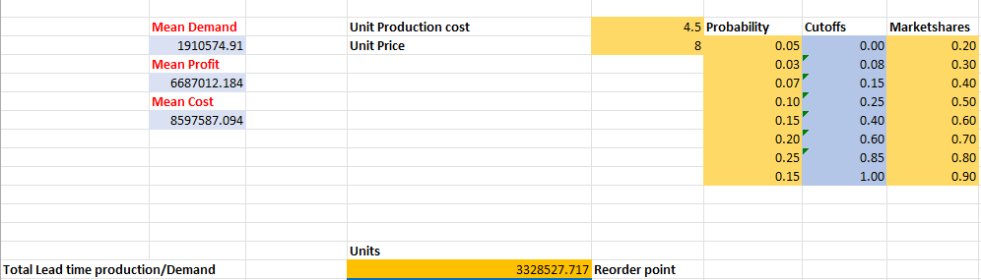

Figure Monte carlo outcome

Figure 10 shows the outcome of the Monte Carlo simulation. Here the unit production cost of £4.5 and unit price of £8 are considered to find the anticipated profit for the company. Based on the simulation, the company's predicted profit can be determined by taking into account market shares at various probability cutoffs, as well as their related unit prices and production costs. The predicted profit is calculated by multiplying each market share by the unit profit (unit price - unit manufacturing cost) and adding them together. The result will be a projected profit for the company based on market conditions and demand levels. Additional research may be required to optimise pricing and production strategies to maximise profit while mitigating risks associated with various market conditions.

**4.0 CONCLUSION AND RECOMMENDATIONS**

**Conclusion:**

In this work, we examined Tesco's demand for green veggies from 1992 to 2018 and created a time series forecasting model to project future demand of the company. We employed additive seasonal decomposition to identify the underlying trends in the data before employing three popular forecasting methods: moving average, simple exponential smoothing, and linear exponential smoothing. We tested the accuracy of these methods using multiple error metrics and discovered that the moving average method performed the best in terms of RMSE, demonstrating its greater predicting capacity.

In addition, we determined the safety stock and reorder point to ensure optimal inventory management and a 97% service level. This will assist Tesco in maintaining appropriate buffer stock to accommodate demand changes and avoid stockouts during lead times.

We used the Monte Carlo simulation in the simulation approach to evaluate the company's estimated lead time demand. We forecasted the company's earnings based on several scenarios by taking into account market shares and their corresponding probability.

**Recommendation:**

Based on our findings, we propose Tesco to use the moving average method for anticipating green vegetable demand because it performed the best in terms of accuracy. This strategy is particularly well suited for dealing with seasonality and cyclical patterns in data.

Maintaining the predicted safety stock level and reorder point will assist Tesco in optimising inventory levels and ensuring smooth operations. This will boost consumer satisfaction by lowering the likelihood of stockouts.

For business decisions, we recommend Tesco employ the Monte Carlo simulation on a regular basis to evaluate alternative market situations and estimate potential risks and profits. This will allow the organisation to make well-informed decisions and alter pricing and production methods as needed to maximise profit and minimise risks.

Tesco may enhance its demand forecasting, inventory management, and overall business performance by implementing these ideas, resulting in improved revenue and a competitive advantage in a highly competitive market.

**REFERENCES**

Brownlee, J. (2020, December 9). *How to decompose time series data into trend and seasonality*. MachineLearningMastery.com. <https://machinelearningmastery.com/decompose-time-series-data-trend-seasonality/>

Hansun, S. (2013). A new approach of moving average method in time series analysis. *2013 Conference on New Media Studies (CoNMedia)*. <https://doi.org/10.1109/conmedia.2013.6708545>

Inderfurth, K. (1991). Safety stock optimization in multi-stage inventory systems. *International Journal of Production Economics*, *24*(1–2), 103–113. <https://doi.org/10.1016/0925-5273(91)90157-o>

Raychaudhuri, S. (2008). Introduction to monte carlo simulation. *2008 Winter Simulation Conference*. <https://doi.org/10.1109/wsc.2008.4736059>